Yandy Tex Application
Latex file compilation
Dviwindo application TeX menu choose LaTeX or press F8
(or)
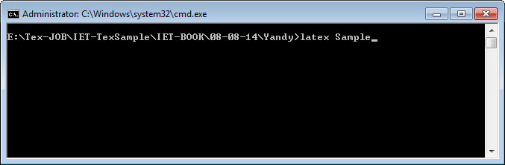
.dvi file to create .ps
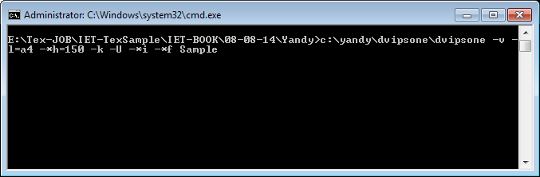
Then create the pdf from .ps file through Adobe Acrobat Distiller (or) Adobe Acrobat.

MikTeX Application
Latex file compilation
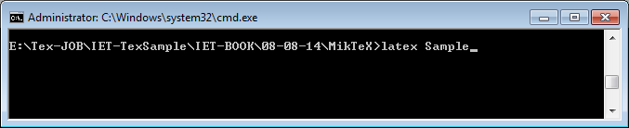

.dvi file to create .ps
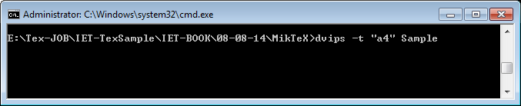
Then create the pdf from .ps file through Adobe Acrobat Distiller or Adobe Acrobat.
OR
.dvi file to create .pdf
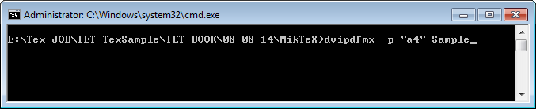

Style names and Codings
Template file using command \documentclass[10pt]{ietbook}
Start of the document \begin{document} ….
End of the document … \end{document}
Running heads \markboth{RH … Verso}{RH … Recto}
Author name \author{ … }
Title Text \chapter{ … }
Section text 1st level \section{ … }
Section text 2nd level \subsection{ … }
Section text 3rd level \subsubsection{ … }
Section text 4th level \paragraph{ … }
Figure starting
(option in position here, top OR bottom) \begin{figure}[!htp]
FOR Figure file name and path \centerline{ … }
For Figure caption text \caption{ ... }
Figure ending \end{figure}
Box starting \begin{boxes}
Box heading text {\boxhead{ … }}
Box text { ... }
Box ending \end{boxes}

